Chapter 10, Problem 12.

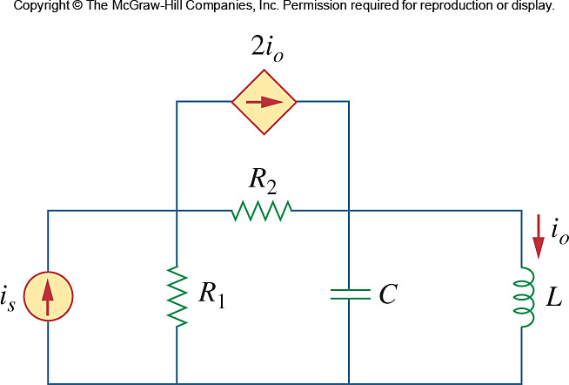
Using Fig. 10.61, design a problem to help other students better understand Nodal analysis.

Figure 10.61
For Prob. 10.12.

